

SENIOR CITIZEN COMPANIONSHIP and TASK-ASSISTANCE APP
Test Case Design Assignment
Submitted in the partial fulfilment for the Course of
CSA1012- Software Engineering
to the award of the degree of
BACHELOR OF ENGINEERING
IN
Artificial Intelligence and Data Science
Submitted by
Harshini P R (192524165)
Under the Supervision of
Dr K Anita Davamani

SIMATS ENGINEERING
Saveetha Institute of Medical and Technical Sciences
Chennai-602105

1. Introduction

1.1 Background
Senior citizens may experience loneliness, reduced social interaction, difficulty completing routine tasks, and challenges in obtaining timely assistance. A digital companionship and task-assistance platform can connect older adults with trusted companions, family members, caregivers or volunteers for non-emergency everyday support. Such a system must be simple to use, reliable, privacy-aware and safe because the users may have limited technical familiarity and may depend on the application for important reminders and assistance.

1.2 Senior Citizen Companionship and Task-Assistance App Overview
The Senior Citizen Companionship and Task-Assistance App is proposed as a user-friendly platform that allows senior citizens to create profiles, request companionship or routine assistance, schedule tasks, receive reminders, communicate with approved helpers, and track task status. Family members, caregivers or approved helpers can view assigned tasks, accept requests, update progress and confirm completion. Notifications and dashboards support the end-to-end experience.

1.3 Purpose of Testing
Because the application handles personal profiles, task requests, schedules, notifications and helper assignments, it is exposed to potential failures such as incorrect task matching, missed reminders, duplicate requests, unauthorized access, network interruptions and inconsistent task status. Systematic software testing is therefore essential to verify correct behaviour under normal, invalid, exceptional and concurrent conditions while protecting senior-citizen information.

1.4 Testing Objectives
- Verify functional correctness of all core application modules.
- Verify correct registration, login, profile and role-management behaviour.
- Verify task creation, scheduling, assignment, status updates and completion.
- Verify companionship-request and helper-matching workflows.
- Verify reminders, notifications and schedule synchronization.
- Verify privacy, authentication, authorization and secure access.
- Verify reliable operation under network, service and database failures.
- Verify behaviour under invalid, exceptional and concurrent conditions.
- Ensure traceability between requirements, test scenarios and test cases.

1.5 Scope of Testing
- User registration, login and session management
- Senior profile and emergency-contact information management
- Task creation, scheduling and editing
- Companionship request and helper matching
- Task acceptance, progress tracking and completion
- Calendar, reminders and notification synchronization
- Family/caregiver/helper dashboards
- Feedback and task-history management
- Data validation, security, reliability, usability and concurrency

2. System Overview and Architecture
The application is organized into layered modules that transform a senior citizen's assistance or companionship request into a completed and recorded service. A senior first creates a request and selects a suitable date and time. The matching module identifies an approved helper or companion, who can accept the request. The task then moves through scheduled, accepted, in-progress and completed states. Notifications keep relevant users informed, while dashboards and reports provide visibility to seniors, family members, helpers and administrators.
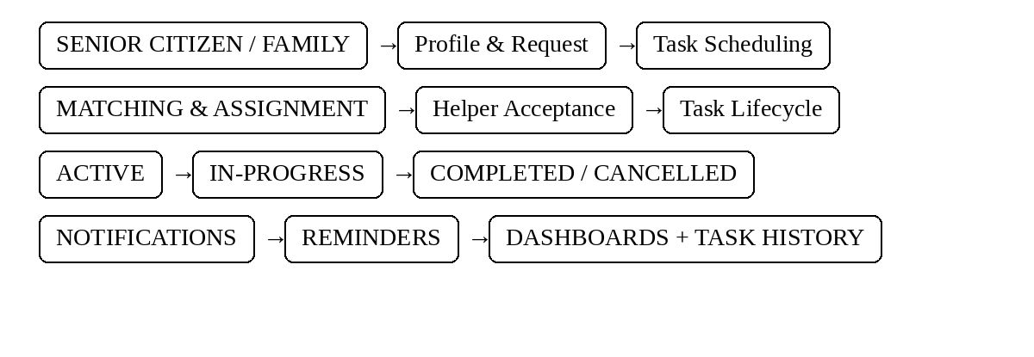
Figure 1: Senior Citizen Companionship and Task-Assistance App Architecture
The end-to-end workflow below illustrates how a task request moves through the platform, including the exception path when a request fails validation.
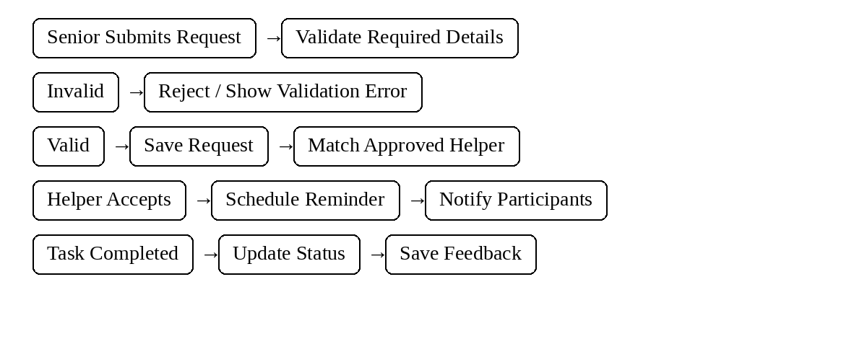
Figure 2: Task Request Processing Workflow

3. Functional Requirements
Req. ID | Functional Requirement | Module | Priority
FR-01 | User Registration and Login | Authentication | High
FR-02 | Password Reset | Authentication | Medium
FR-03 | Senior Profile Creation and Update | Profile Management | High
FR-04 | Emergency Contact Information | Profile Management | Medium
FR-05 | Task / Assistance Request Creation | Task Management | High
FR-06 | Task Scheduling and Rescheduling | Task Management | High
FR-07 | Companionship Request | Companionship | High
FR-08 | Helper Matching and Assignment | Matching | High
FR-09 | Helper Accept / Reject Request | Matching | High
FR-10 | Task Status Tracking | Task Lifecycle | High
FR-11 | Reminder and Calendar Synchronization | Scheduling | Medium
FR-12 | Task Cancellation Handling | Task Lifecycle | Medium
FR-13 | Task Completion Confirmation | Task Lifecycle | High
FR-14 | Task/Appointment Notification | Notifications | High
FR-15 | Missed-Task / Reminder Notification | Notifications | Medium
FR-16 | Feedback and Rating | Feedback | Medium
FR-17 | Family/Caregiver Dashboard | Visualization | High
FR-18 | Helper Dashboard | Visualization | High
FR-19 | Admin User/Task Monitoring | Visualization | Medium
FR-20 | Task History and Report Generation | Reporting | Medium
FR-21 | Privacy and Consent Management | Security | High

3. Functional Requirements
Req. ID | Functional Requirement | Module | Priority
FR-01 | User Registration and Login | Authentication | High
FR-02 | Password Reset | Authentication | Medium
FR-03 | Senior Profile Creation and Update | Profile Management | High
FR-04 | Emergency Contact Information | Profile Management | Medium
FR-05 | Task / Assistance Request Creation | Task Management | High
FR-06 | Task Scheduling and Rescheduling | Task Management | High
FR-07 | Companionship Request | Companionship | High
FR-08 | Helper Matching and Assignment | Matching | High
FR-09 | Helper Accept / Reject Request | Matching | High
FR-10 | Task Status Tracking | Task Lifecycle | High
FR-11 | Reminder and Calendar Synchronization | Scheduling | Medium

4. Non-Functional Requirements
Non-functional requirements address the qualities the application must exhibit beyond individual features, with particular emphasis on usability for senior citizens, privacy of personal information, reliability of reminders and task states, availability during scheduled assistance, scalability and data consistency.
ID | Requirement | Description | Testing Objective
NFR-01 | Performance | Requests, dashboard updates and notifications should respond within acceptable time. | Verify response time and notification latency.
NFR-02 | Security | Only authenticated and authorized users can access protected functions. | Verify authentication, authorization and access control.
NFR-03 | Reliability | The system should recover from network/service/database disruptions without losing confirmed tasks. | Verify failure and recovery behaviour.
NFR-04 | Availability | The application should remain accessible during scheduled tasks with minimal downtime. | Verify accessibility across sessions and restarts.
NFR-05 | Usability | Controls, schedules, reminders and task status should be clear and easy for seniors to understand. | Verify clarity and ease of use.
NFR-06 | Scalability | The platform should support increasing users, tasks and concurrent requests without functional degradation. | Verify behaviour under increasing load.
NFR-07 | Data Integrity / Consistency | Task status, assignments and schedules must remain accurate without unintended duplication or loss. | Verify ordering, duplication and consistency.
NFR-08 | Maintainability | Modules should allow changes to matching, scheduling and notifications with minimal impact. | Verify modular testability.
NFR-09 | Compatibility | The application should function correctly across supported browsers and devices. | Verify supported access modes.
NFR-10 | Privacy | Profiles, contact details, schedules and task history must not be exposed to unauthorized users. | Verify data isolation and consent enforcement.

5. Test Scenario Identification
Test scenarios were identified by systematically walking through each functional and non-functional requirement and considering positive, negative, boundary, exceptional, security, usability and concurrency conditions relevant to senior-citizen assistance and companionship workflows.

6. Test Design Techniques
Four complementary test design techniques were applied to the application's input fields and stateful task workflow: Equivalence Partitioning, Boundary Value Analysis, Decision Table Testing and State Transition Testing. Together these techniques improve coverage of valid/invalid inputs and task-lifecycle behaviour.

6.1 Equivalence Partitioning
Equivalence Partitioning was applied to important inputs such as task duration, scheduled date/time, task ID and profile fields by dividing possible values into valid and invalid classes.

Partition | Description | Representative Value | Expected Handling
EP-1 | Valid task duration | 60 minutes | Accepted and scheduled normally
EP-2 | Below minimum duration | 0 minutes | Rejected as invalid duration
EP-3 | Above maximum duration | 25 hours | Rejected as excessive duration
EP-4 | Missing task description | null | Rejected with missing-data error
EP-5 | Invalid phone/contact format | abc123 | Rejected with format error
EP-6 | Valid registered task ID | T-2001 | Request accepted and mapped to task
EP-7 | Invalid task ID | T-9999 | Request rejected and error logged
EP-8 | Empty task ID |  | Mandatory-field error
EP-9 | Cancelled task ID | T-1000 (cancelled) | Update rejected with task-cancelled error

6.1 Equivalence Partitioning
Representative values are selected to cover one input from each identified partition, minimizing redundant test cases while preserving coverage of all valid and invalid input classes.

6.2 Boundary Value Analysis
Boundary Value Analysis was applied to task duration and scheduling limits. For design purposes, a minimum task duration of 15 minutes and a maximum duration of 8 hours are assumed. These values are explicit testing assumptions rather than confirmed production settings.
Test Point | Value | Expected Handling
Minimum − 1 | 14 min | Rejected — below minimum duration
Minimum | 15 min | Accepted — lower boundary
Minimum + 1 | 16 min | Accepted — valid range
Nominal | 60 min | Accepted — typical value
Maximum − 1 | 7 h 59 min | Accepted — within valid range
Maximum | 8 h | Accepted — upper boundary
Maximum + 1 | 8 h 1 min | Rejected — exceeds maximum duration

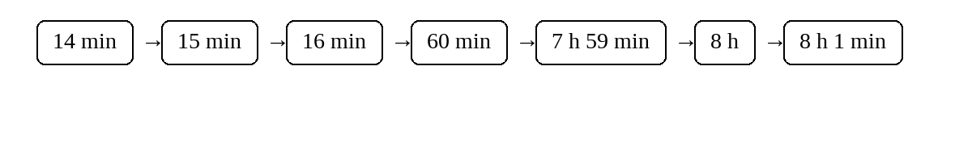
Figure 3: Boundary Value Analysis for Task Duration

6.3 Decision Table Testing
A decision table was constructed for helper assignment and reminder behaviour using three binary conditions and four possible resulting actions.
- C1 = Approved helper is available for the requested slot
- C2 = Helper accepts the task
- C3 = Task is within the reminder window
- A1 = Assign helper; A2 = Keep request pending; A3 = Send reminder; A4 = Offer alternate helper
Rule | C1 | C2 | C3 | Resulting Action(s)
R1 | Y | Y | Y | A1 + A3 (Assign, Reminder)
R2 | Y | Y | N | A1 (Assign)
R3 | Y | N | Y | A3 + A4 (Reminder, Alternate)
R4 | Y | N | N | A4 (Offer Alternate)
R5 | N | Y | Y | A3 + A4 (Reminder, Alternate)
R6 | N | Y | N | A4 (Offer Alternate)
R7 | N | N | Y | A3 + A4 (Reminder, Alternate)
R8 | N | N | N | A2 (Pending)

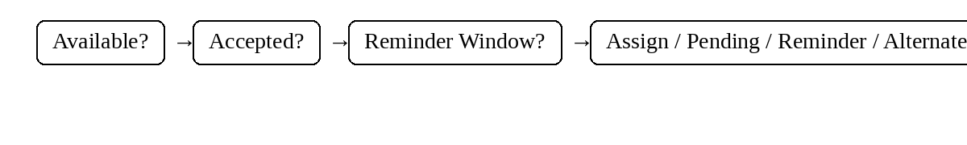
Figure 4: Decision Table for Helper Assignment and Reminder Logic

6.4 State Transition Testing
State Transition Testing was applied to the task lifecycle, covering the successful path from request creation through completion and the exception paths taken when a request is rejected, cancelled or a helper becomes unavailable.
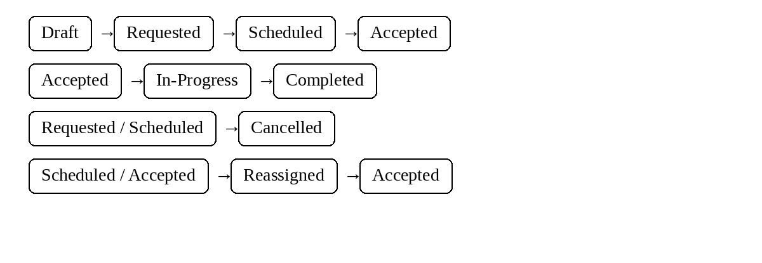
Figure 5: Senior Task Lifecycle State Transition Model

7. Detailed Test Case Design
The test cases below implement the scenarios identified in Section 5, organized by module. As this is a test-case design exercise, no execution has been performed: Actual Result is recorded as 'Not Executed' and Pass/Fail Status as 'Not Run' for every test case. Test data represents realistic illustrative values for design purposes.

7.1 Authentication Test Cases
TC ID | Req. ID | Test Scenario | Test Steps | Test Data | Expected Result
TC-001 | FR-01 | Valid login | Open login; enter valid credentials; click Login | user: senior_asha / pass: Senior@2026 | User authenticated and sent to dashboard.
TC-002 | FR-01 | Invalid password | Enter valid username and wrong password | user: senior_asha / pass: wrongPass1 | Invalid credentials; access denied.
TC-003 | FR-01 | Invalid username | Enter unregistered username and password | user: unknown_user / pass: Senior@2026 | User not found; access denied.
TC-004 | FR-01 | Empty credentials | Leave fields blank; click Login | username: '' / password: '' | Mandatory-field validation shown.
TC-005 | FR-01 | Multiple failed attempts | Enter wrong password five times | wrong1...wrong5 | Temporary lock/warning after threshold.

7.2 Profile and Task Management
TC ID | Req. ID | Test Scenario | Test Steps | Test Data | Expected Result
TC-006 | FR-03 | Create valid senior profile | Open profile; enter details; save | Name: Asha; Age: 70; City: Chennai | Profile created successfully.
TC-007 | FR-03 | Missing profile detail | Leave mandatory field blank; save | Name: ''; Age: 70 | Mandatory-field error.
TC-008 | FR-04 | Invalid emergency contact | Enter invalid contact format | Contact: abc123 | Invalid-contact error.
TC-009 | FR-05 | Create valid task request | Enter task details and submit | Task: Pharmacy pickup; Duration: 60 min | Request created.
TC-010 | FR-06 | Invalid schedule | Set end time before start | Start: 10:00; End: 09:00 | Date/time validation error.
TC-011 | FR-06 | Schedule in the past | Select past date/time | Date: 10-Aug-2026 | Past scheduling rejected.

7.3 Task Request and Assignment
TC ID | Req. ID | Test Scenario | Test Steps | Test Data | Expected Result
TC-012 | FR-05 | Valid assistance request | Open task request; enter valid details; submit | Task: Grocery assistance; 60 min | Request accepted and saved.
TC-013 | FR-05 | Missing task description | Submit with description blank | Description: '' | Mandatory-field error.
TC-014 | FR-05 | Invalid task duration | Enter zero duration | Duration: 0 min | Invalid-duration error.
TC-015 | FR-05 | Request after account disabled | Submit request using disabled account | Account: disabled | Request rejected.
TC-016 | FR-07 | Valid companionship request | Select companionship; choose time; submit | Companionship: 1 hour | Companionship request created.
TC-017 | FR-07 | Duplicate companionship request | Submit same request twice | Same senior/time/details | Duplicate request prevented.
TC-018 | FR-08 | Helper matching | Create request with available helper | Slot: 15-Aug-2026 10:00 | Suitable helper shown.
TC-019 | FR-08 | No helper available | Create request for unavailable slot | Slot: fully booked | Request remains pending/alternate offered.
TC-020 | FR-09 | Helper accepts request | Helper opens request and accepts | Task ID: T-2001 | Task status becomes Accepted.
TC-021 | FR-09 | Helper rejects request | Helper rejects assigned request | Task ID: T-2002 | Request returns to matching/pending state.
TC-022 | FR-09 | Helper accepts after cancellation | Try accepting cancelled task | Task ID: T-2003; status Cancelled | Acceptance rejected.

7.4 Task Status Tracking
TC ID | Req. ID | Test Scenario | Test Steps | Test Data | Expected Result
TC-023 | FR-10 | Start accepted task | Helper starts scheduled task | Task T-2010 | Status changes to In-Progress.
TC-024 | FR-10 | Complete task | Helper marks task completed | Task T-2010 | Status changes to Completed.
TC-025 | FR-10 | Invalid status transition | Try Completed → In-Progress | Task status Completed | Transition rejected.
TC-026 | FR-12 | Cancel scheduled task | Senior cancels before start | Task T-2011 | Task becomes Cancelled; users notified.
TC-027 | FR-12 | Cancel completed task | Try cancelling completed task | Task T-2012 | Cancellation rejected.

7.5 Scheduling, Reminders and Synchronization
TC ID | Req. ID | Test Scenario | Test Steps | Test Data | Expected Result
TC-028 | FR-11 | Reminder created | Schedule future task | Task time: 18-Aug-2026 10:00 | Reminder is created for configured interval.
TC-029 | FR-11 | Calendar synchronization | Open task on two supported clients | Same task and timestamp | Both clients show same schedule.
TC-030 | FR-11 | Rescheduled task updates reminder | Change task time | 10:00 → 11:00 | Calendar and reminder update.
TC-031 | FR-11 | Past reminder suppression | Open completed task | Status: Completed | No future reminder is sent.
TC-032 | FR-11 | Reconnect restores schedule | Disconnect and reconnect client | Disconnect: 20 sec | Current schedule and task state restored.

7.6 Task Completion and Feedback
TC ID | Req. ID | Test Scenario | Test Steps | Test Data | Expected Result
TC-033 | FR-13 | Completion confirmation | Helper marks task complete | Task T-2020 | Senior sees completed status.
TC-034 | FR-13 | Completion without acceptance | Try completing unaccepted task | Task status Requested | Completion rejected.
TC-035 | FR-16 | Submit valid feedback | Senior rates completed task | Rating: 5; Comment: Helpful | Feedback saved.
TC-036 | FR-16 | Invalid rating | Submit rating outside allowed range | Rating: 7 | Validation error.
TC-037 | FR-16 | Feedback for unfinished task | Open feedback before completion | Task status In-Progress | Feedback option unavailable.

7.7 Notifications
TC ID | Req. ID | Test Scenario | Test Steps | Test Data | Expected Result
TC-038 | FR-14 | Assignment notification | Helper accepts task | Task T-2030 | Senior receives assignment notification.
TC-039 | FR-14 | Reminder notification | Task reaches reminder window | Time remaining: 30 min | Senior/helper receive reminder.
TC-040 | FR-15 | Missed-task notification | Task time passes without completion | Status: Accepted; end time passed | Missed-task notification is sent.
TC-041 | FR-14 | Cancellation notification | Senior cancels scheduled task | Task T-2031 | Assigned helper is notified.
TC-042 | FR-14 | Notification service failure | Simulate notification downtime | Service: unreachable | Task workflow continues; failure logged for retry.

7.8 Dashboard and Reporting
TC ID | Req. ID | Test Scenario | Test Steps | Test Data | Expected Result
TC-043 | FR-17 | Family dashboard loading | Login as family member; open dashboard | 3 active senior tasks | Dashboard shows correct tasks/status.
TC-044 | FR-18 | Helper dashboard | Login as helper; open dashboard | 4 assigned tasks | Correct assigned tasks displayed.
TC-045 | FR-19 | Admin monitoring | Open admin task panel | 5 active requests | Panel shows correct real-time status.
TC-046 | FR-20 | Generate valid report | Select valid date range | 01-Aug-2026 to 31-Aug-2026 | Report generated with task data.
TC-047 | FR-20 | Report with no data | Select future range | Future date range | Clear no-data state shown.

7.9 Security
TC ID | Req. ID | Test Scenario | Test Steps | Test Data | Expected Result
TC-048 | NFR-02 | Unauthorized access | Open protected admin URL without login | /admin | Access denied; redirected to login.
TC-049 | NFR-02 | Invalid session | Call API with expired session token | Token: expired | Request rejected with authentication error.
TC-050 | NFR-02 | Role-based restriction | Senior attempts helper-only function | Role: Senior | Access denied.
TC-051 | NFR-02 | Malicious input handling | Submit script/injection-style text | <script>alert(1)</script> | Input sanitized/rejected; no code execution.

7.10 Privacy and Consent
TC ID | Req. ID | Test Scenario | Test Steps | Test Data | Expected Result
TC-052 | NFR-10 | Profile privacy | Senior A attempts to view Senior B profile | Different accounts | Access denied unless authorized.
TC-053 | NFR-10 | Task-history isolation | Family member opens unrelated senior history | Wrong senior ID | Data is not exposed.
TC-054 | NFR-10 | Consent withdrawal | User withdraws optional data-sharing consent | Consent: Off | Optional sharing stops and state is recorded.

7.11 Reliability and Exception Handling
TC ID | Req. ID | Test Scenario | Test Steps | Test Data | Expected Result
TC-055 | NFR-03 | Network interruption | Disconnect while submitting a task | Connectivity interrupted | Error shown; no partial duplicate task.
TC-056 | NFR-03 | Backend API failure | Simulate server error during request | HTTP 500 | Graceful error; task state not corrupted.
TC-057 | NFR-03 | Database failure | Simulate database unavailable during update | DB unreachable | Update rejected safely; failure logged.
TC-058 | NFR-03 | Recovery after restoration | Restore API/DB/network | Service restored | Normal operation resumes.

7.12 Concurrency and Data Consistency
TC ID | Req. ID | Test Scenario | Test Steps | Test Data | Expected Result
TC-059 | NFR-07 | Simultaneous task requests | Two clients submit same time slot concurrently | Same senior/time | System prevents conflicting duplicate assignment and keeps consistent state.

8. Requirement Traceability Matrix (RTM)
Req. ID | Requirement | Scenario IDs | Test Case IDs | Coverage
FR-01 | Registration/Login | TS-01–TS-05 | TC-001–TC-005 | Fully Covered
FR-03 | Senior Profile | TS-06–TS-07 | TC-006–TC-007 | Fully Covered
FR-04 | Emergency Contact | TS-08 | TC-008 | Fully Covered
FR-05 | Task Request | TS-09, TS-12–TS-15 | TC-009, TC-012–TC-015 | Fully Covered
FR-06 | Task Scheduling | TS-10–TS-11 | TC-010–TC-011 | Fully Covered
FR-07 | Companionship Request | TS-16–TS-17 | TC-016–TC-017 | Fully Covered
FR-08 | Helper Matching | TS-18–TS-19 | TC-018–TC-019 | Fully Covered
FR-09 | Helper Acceptance | TS-20–TS-22 | TC-020–TC-022 | Fully Covered
FR-10 | Task Status | TS-23–TS-25 | TC-023–TC-025 | Fully Covered
FR-11 | Reminders/Calendar | TS-28–TS-32 | TC-028–TC-032 | Fully Covered
FR-12 | Cancellation | TS-26–TS-27 | TC-026–TC-027 | Fully Covered
FR-13 | Completion | TS-33–TS-34 | TC-033–TC-034 | Fully Covered
FR-14 | Notifications | TS-38–TS-42 | TC-038–TC-042 | Fully Covered
FR-15 | Missed Task | TS-40 | TC-040 | Fully Covered
FR-16 | Feedback | TS-35–TS-37 | TC-035–TC-037 | Fully Covered
FR-17–FR-20 | Dashboards/Reports | TS-43–TS-47 | TC-043–TC-047 | Fully Covered
FR-21 | Privacy/Consent | TS-52–TS-54 | TC-052–TC-054 | Fully Covered
NFR-02 | Security | TS-48–TS-51 | TC-048–TC-051 | Fully Covered
NFR-03 | Reliability | TS-55–TS-58 | TC-055–TC-058 | Fully Covered
NFR-07 | Data Integrity | TS-59 | TC-059 | Fully Covered
NFR-10 | Privacy | TS-52–TS-54 | TC-052–TC-054 | Fully Covered

8. Requirement Traceability Matrix
The Requirement Traceability Matrix maps functional and important non-functional requirements to the test scenarios and test cases that exercise them, ensuring that significant requirements have corresponding test coverage.
Requirement Coverage = (Number of requirements fully covered / Total requirements listed) × 100. For this design, the mapped requirement set is treated as fully covered because each listed requirement has at least one corresponding test case.

9. Test Coverage Analysis
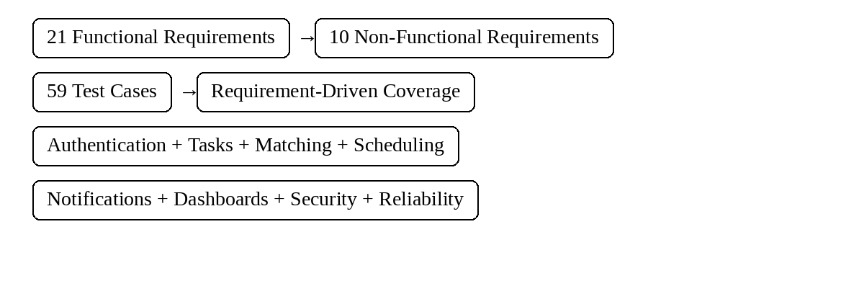
Figure 6: Senior Citizen App Test Coverage Analysis
Metric | Value
Total Functional Requirements | 21
Total Non-Functional Requirements | 10
Total Test Scenarios | 59
Total Test Cases | 59
Requirements Fully Covered | 31 / 31
Requirements Not / Partially Covered | 0 / 31
Requirement Coverage | 100.0%

Execution-based pass percentage is not calculated because this document represents test-case design rather than executed testing.

10. Security, Reliability and Quality Analysis

10.1 Security
- Authentication of users before accessing protected profile, task or dashboard functions.
- Authorization and role-based access between senior, family/caregiver, helper and administrator functions.
- Protection of senior profile, contact and task information from unauthorized access.
- Input validation to guard against malicious or malformed task/profile submissions.
- Secure handling of communications between client and backend services.
- Controlled access to task history and personal data.

10.2 Reliability
- Graceful handling of network interruptions without losing confirmed task information.
- Recovery behaviour following backend API or database failures.
- Correct synchronization of task status and schedules after reconnection.
- Fallback behaviour when notification services are unavailable.
- Logging and monitoring of failure events for diagnosis and audit.

10.3 Data Quality
- Detection and rejection of missing or malformed task submissions.
- Prevention of duplicate task requests.
- Validation of invalid or out-of-range task durations and schedules.
- Consistency of timestamps and task states.
- Resolution of conflicting assignments under concurrent updates.

10.4 Usability
- Clear task descriptions, large/simple controls and understandable status information.
- Visibility and comprehensibility of reminders and notifications.
- Ease of understanding companionship and assistance request options.
- Understandable feedback and task-completion messages.
- Accessibility across supported devices.

10.5 Sustainability
Testing the correctness and reliability of task scheduling, matching, reminders and completion directly supports the application's goal of improving access to companionship and routine assistance. Reliable workflows reduce missed appointments, repeated requests and administrative effort, while privacy controls support trust between seniors, families and approved helpers.

11. Conclusion and References

11.1 Conclusion
This document has presented a comprehensive test-case design for the Senior Citizen Companionship and Task-Assistance App, covering functional and non-functional requirements, scenario identification and detailed test cases across authentication, profile management, task requests, companionship, helper matching, scheduling, task status, notifications, dashboards, security, privacy, reliability and concurrency. The application of Equivalence Partitioning and Boundary Value Analysis strengthens coverage of valid and invalid input classes and their boundaries. Decision Table Testing captures the combinational logic of helper assignment and reminders, while State Transition Testing verifies the task lifecycle and exception paths such as cancellation and reassignment. Together with the Requirement Traceability Matrix, these techniques provide a broad requirement-driven foundation for future test execution.

11.2 Assumptions
- Task duration limits, reminder intervals and helper-matching rules used in testing are design assumptions because exact production limits were not supplied.
- Test data values are illustrative and are intended for test-case specification only.
- No actual execution results, deployment outcomes or production user data are claimed; all cases are design cases.
- The application is intended for routine companionship and task assistance; emergency situations should be handled through appropriate real-world emergency services rather than relying solely on the app.

11.3 References
[1] IEEE Std 829-2008, IEEE Standard for Software and System Test Documentation, IEEE, 2008.
[2] ISTQB, Certified Tester Foundation Level Syllabus, International Software Testing Qualifications Board, 2018.
[3] G. J. Myers, C. Sandler, and T. Badgett, The Art of Software Testing, 3rd ed., Wiley, 2011.
[4] P. Ammann and J. Offutt, Introduction to Software Testing, 2nd ed., Cambridge University Press, 2016.
[5] R. S. Pressman and B. R. Maxim, Software Engineering: A Practitioner's Approach, 9th ed., McGraw-Hill Education, 2019.

